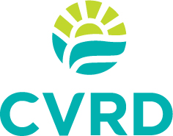
NOTICE
to customers of the
SALTAIR WATER SYSTEM
The Cowichan Valley Regional District (CVRD) will be performing maintenance causing an interruption of service on:
MONDAY, MAY 13, 2019
between
8:00 am and 5:00 pm
Prior to service interruptions, we recommend you store an adequate water supply to address your residence’s needs. Following service interruptions, you may experience cloudy water for a short period of time and should run the faucets until the water becomes clear. We realize that the construction activity could inconvenience you, and we will try to do our best to have the work completed on or before schedule.

Should you have any questions regarding the above, please call the CVRD’s Engineering Services Department at 250.746.2530.

The CVRD appreciates your patience during this interruption of service.

